CSE220: Data Structures (Lab)

Fall 2024

Lab Quiz - 05

Duration: 30 Minutes

| Name: | ID: | Section: |
| --- | --- | --- |

### **Question 1 [15 Points]**

Ayaan is using Google Maps to plan his journey from Khulna to Sylhet. In this system, each city along the route is represented as a node in a Binary Search Tree (BST). Each node contains the name of the city, the tax required to enter that city, and connections to two other cities: one to the left and one to the right.

The journey begins at the root node, which represents the starting city, Khulna. As Ayaan traverses the tree toward his target city, Sylhet, he keeps track of the total crossing tax for all the cities along the way. If the target city does not exist in the tree, the system will notify Ayaan that the "route does not exist."

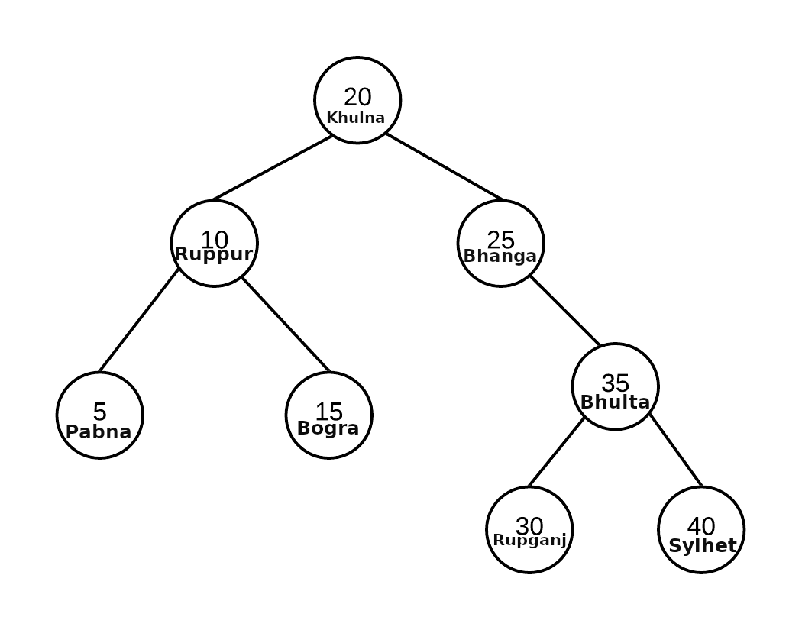

**Hints:**

* **You need to use a customized Node class which will contain 2 different data (tax and city).**
* **The root(Khulna) city's tax is excluded.**

| **Sample Input** | **Sample Output** | **Explanation** |
| --- | --- | --- |
| crossing_tax(root,”Sylhet”,40) | Total Tax: 100 tk | 25+35+40 = 100 |
| crossing_tax(root,”Dhaka”,34) | route does not exist |  |

**You need to construct the node class and the BST by yourself.**